Soren Kierkegaard

Episode 1:
Introduction:
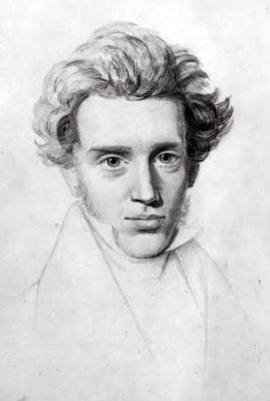
Soren Kierkegaard (1813-1855) was a man who did not consider himself a philosopher but rather a poet. He showed distain to the rigid academic systems that theology and philosophy were producing during his time, and his writings were often in complete opposition to their way of thinking. For Kierkegaard, the importance of philosophy lay with self-discovery; developing into a true, authentic self. A quote from Kierkegaard presents this view:
“What I really lack is to be clear in my mind what I am to do, not what I must know…what matters is to find a purpose…to find a truth that is true for me, to find the idea for which I am willing to live and die…This is what my soul thirst for as the African desert thirsts for water.”
The importance is ‘truth as subjectivity’. A person is a subject, not an object, therefore when considering the question of how one ought to live we cannot simply rely on an all-encompassing logical theory such as the Hegelian system presented to Kierkegaard. Kierkegaard challenges the individual to think for themselves, to take ownership of their own choices and to continuously strive towards being a true self.
For Kierkegaard, he dedicated himself to life of faith. However, not in the same way that many Danish people during his time would have recognised. He famously attacked the Danish Church in his later writings for not holding Christianity to the standard that Jesus required.
Before he died he rejected Mass from a Priest, requesting that it be done by a lay-person. This request was declined. At his funeral large crowds gathered, many who were there to protest the fact he was being buried at the official Church. It was seen as an insult to the man who opposed their way of life.
Kierkegaard’s writings would not be fully appreciated during his time but would later go on to influence great thinkers such a Ludwig Wittgenstein, Karl Barth, and Jean Paul Sartre, amongst many others.
“Kierkegaard was by far the most profound thinker of the last century. Kierkegaard was a saint.” - Ludwig Wittgenstein

Brief outline of Kierkegaard and his life.
Michael Pedersen Kierkegaard – How did he influence Soren’s life and writings?
"An old man, who himself suffered exceedingly from melancholy, has a son in his old age, who inherits all this melancholy". (Kierkegaard in a note from 1846)
Michael’s (1756-1838) early life was spent in poverty, working as a field-hand in a church yard. During this time, an event occurred which influenced his life greatly and is a revelation that he eventually disclosed to his son Soren.
Michael, while feeling alone and a sense of suffering towards his poor life, cursed God for his troubles. The act of blasphemy was a choice that occupied his thoughts throughout his life, so much so that he began to believe that his family would all meet their demise before him. This included the superstition which predicted his 7 children would all fail to reach the age of 34. Something that almost appeared to be the case with all but Soren and his older brother Peter surviving the “curse”.
Michael did not remain poor for much of his life; he proved himself to be an effective trader and a shrewd social climber. By interacting with influential members of the Dutch Clergy and others in high society, Michael’s status grew. Furthermore, while many lost out financially when the British attacked Danish harbours, he did not. This wealth and social standing gave a great platform for his children to succeed in the city of Copenhagen.
As a father, Michael made a great impression on the young Soren. He was an intense yet imaginative man and is said to be to have been excellent at debating and articulating his point of view. He was also a devout Christian whose views on the individual’s salvation through Jesus, compiled with the belief that Jesus was denounced and ultimately killed by the crowed for baring the truth, gave shape to Soren’s future writings on faith and his attack upon Christendom.
"Even as a small child I was told, as solemnly as possible: that everyone spat at Christ (who, indeed, was the truth), that the multitude (those who passed by) spat at him and said: 'Shame on you.' I have kept this deep in my heart. This thought is my life" (Søren Kierkegaard, p. 7f.).
Soren was the youngest child out of 7 and arguably his father’s favourite. There are examples of how he would help Soren out financially when he had frivolously wasted money on an extravagant lifestyle. He also showed patience with Soren when he dragged his feet with regards to his studies. This was all to the annoyance of his older brother Peter who was considered to be a model student and a sensible, well respected young man.
When Michael died at the age of 82 he left a large amount of money for Soren. This allowed him to pursue his life of writing without the concern of making money, which as it turns out, was needed because very few of his published works made a profit. The money he had lasted right up until he passed away. Scholars point out that it is not surprising this was the case. Soren was in bad health which remained manageable while he could afford comfort, but would have worsened as he ran low on funds. He died in hospital a few days after collapsing in the street.

Relationship with Regine Olsen- How did she influence Soren’s life and writings?
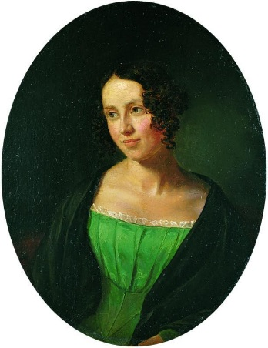
Regine Olsen was the love of Kierkegaard’s life yet also a casualty of the commitment to his authorship. Soren and Regine met as a result of being within the same social circles. She was 15 years old at the time of their first meeting, while he was a much more mature 24. He admired her personality and intelligence but did not pursue anything overtly romantic for 3 years. Soren did however frequent the Olsen household, befriending her father as well as her tutor who also was considered a suitor for Regine.
By the time he was 27, Soren had Regine at the forefront of his thoughts and had been planning out the best time to approach her with intentions of marriage. When he found an opportunity to be alone with Regine at her family home, Soren confessed to be deeply in love with her and proposed. He then received her father’s blessing and they became engaged. Soren appears to have regretted his decision very early on in their engagement, not because he had fallen out of love with Regine but rather his commitments laid elsewhere.
Soren’s life was to be dedicated to his authorship and the pursuit of faith. After 13months he broke off the engagement, much to his own and Regine’s dismay. The break up was not an easy process for either of them. Regine knew that Soren still remained in love with her and she, amongst others, tried tirelessly to make him reverse his decision. Soren stood firm and went to great lengths to appear an antagonist in the eyes of the public so they would blame him rather than Regine.
The decision Soren made was one that rippled throughout his life; in his thoughts, journals and his books. The importance of this choice ultimately lies with its connection to his philosophy and theology. His aim was to write polemics, different points of view to challenge people’s perspectives on their understanding of themselves and their faith. He puts the emphasis of the individual and their own choices towards to the religious sphere of existence by interpreting the writing in their own way. It is clear that Soren felt his life must be led as an individual. Perusing the type of writing career he engaged in, could only be achieved without the responsibility of married life.

Soren’s philosophical approach – Socrates vs. Hagel:
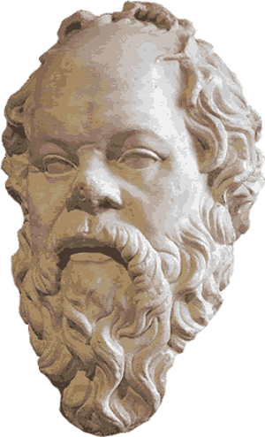
What is Socratic irony and how did it influence the philosophy of Kierkegaard?
“To be ironic is to pretend ignorance, or adopt a stance opposite from what you know to be the truth for the sake of the truth” (Kierkegaard: A Single Life).
This method of enquiry is what Socrates used with the people of his time to get them to discover their own ignorance. By asking someone to define a concept such as courage, Socrates could ask questions from a false position of unfamiliarity to explain their opinions further, with the intention of them revealing the weakness of their argument. For Kierkegaard “Socrates represents a position of ‘infinite negativity’: always demolishing but not able to build. In his longing for a universal Truth, Socrates rejected all the temporary “truths” of his society. This might be negative but at least it does not topple one lesser god only to put another one up in its place.” (Kierkegaard: A Single Life)
Kierkegaard sees irony as a useful tool, one which can be used to effectively expose a lie. However, it fails when it becomes a new lie for someone to live by. There is no real sense of authenticity or truth to the life of irony.
Kierkegaard embraces Socratic irony in much of his pseudonymous authorship. By presenting different ways of existence, he is inviting the reader to see themselves or their society reflected back at them. They are then free to interpret the text and choose which way of life is best for them. This method does not involve clear direction, nor does it offer a logical path for one to understand fully. It forces the reader into reflection, and it is here where Kierkegaard hopes change can be made.
“To stop a man on the street and stand still while talking to him, is not so difficult as to say something to a passer-by in passing, without standing still and without delaying the other, without attempting to persuade him to go the same way, but giving him instead an impulse to go precisely his own way. Such is the relation between one existing individual and another, when the communication concerns the truth as existential inwardness.” (Concluding Unscientific Postscript to Philosophical Fragments)

Example of Socrates (Euthyphro dilemma) Wikipedia:
“In an example of Socratic irony, Socrates says that Euthyphro obviously has a clear understanding of what is pious and impious (he is facing a formal charge of impiety, Socrates expresses the hope to learn from Euthyphro, all the better to defend himself in the trial.
Euthyphro says that what lies behind the charge of impiety presented against Socrates, by Meletus and the others, is Socrates' claim that he is subjected to a daimon, (divine sign) which warns him of various courses of action. (3b) From the perspective of some Athenians, Socrates expressed scepticism of the accounts about the Greek gods, which he and Euthyphro briefly discuss, before proceeding to the main argument of their dialogue: the definition of “piety”. Moreover, Socrates further expresses critical reservations about such divine accounts that emphasise the cruelty and inconsistent behaviour of the Greek gods, such as the castration of the early sky-god Uranus, by his son Cronus; a story Socrates said is difficult to accept. (6a–6c)
After claiming to know and be able to tell more astonishing divine stories, Euthyphro spends little time and effort defending the conventional, Greek view of the gods. Instead, he is led to the true task at hand, as Socrates forces him to confront his ignorance, by pressing Euthyphro for a definition of “piety”; yet, Socrates finds flaw with each definition of “piety” proposed by Euthyphro.(6d ff.)
At the dialogue's conclusion, Euthyphro is compelled to admit that each of his definitions of “piety” has failed, but, rather than correct his faulty logic, he says that it is time for him to leave, and excuses himself from their dialogue. To that end, Socrates concludes the dialogue with Socratic irony: Since Euthyphro was unable to define “piety”, Euthyphro has failed to teach Socrates about piety. Therefore, from his dialogue with Euthyphro, Socrates received nothing helpful to his defence against a formal charge of impiety. (15c ff.)”

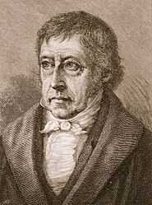
What was Hegel’s systematic philosophy and why did Kierkegaard oppose it?

Hegel’s system was designed to be an all-encompassing theory of knowledge which set out to show how history is progressing towards an end point. Each civilisation is building from the last, improving, and will eventually end in self-realisation of the ‘Divine Mind’.
This is known as the ‘dialectic’:
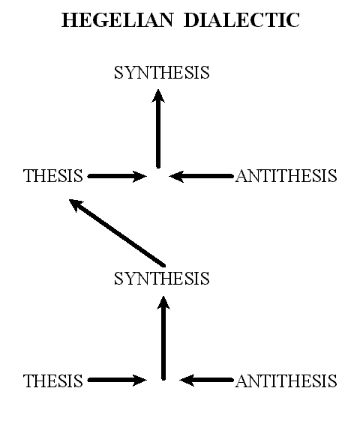
This involves progress through the compromise of conflicting ideas. There is, according to Hegel, always a thesis which is then challenged by an antithesis. This will then result in a synthesis. This began with the friction of the ‘Dive Mind’ between being and nothingness and will continue to progress until there is complete self-actualisation:
“The revelation of God was not to be found in a person or a holy text but in the development of a culture’s history. The unfolding spirit is first encountered in a society’s art. This artistic expression is then given meaning and explanation in that society’s religion. Finally, it is philosophy that explains the religion. The spirit is ever developing and thus the Divine is revealed in mankind’s highest achievements. To see the latest and best manifestation of the Divine Mind in the world, all one has to do is look at the latest and best manifestation of the world’s civilisation.” (Kierkegaard: A Single Life).
This was rejected by Kierkegaard throughout his writings. He did not think it was possible to come to such a complete objective truth about human life.
“The whole of existence cannot be systematized, Kierkegaard insisted, because existence is not yet whole; it is incomplete and in a state of constant development. Hegel attempted to introduce mobility into logic, which, said Kierkegaard, is itself an error in logic. The greatest of Hegel’s errors, however, was his claim that he had established the objective theory of knowledge. Kierkegaard countered with the argument that subjectivity is truth. As he put it, “The objective uncertainty maintained in the most passionate spirit of dedication is truth, the highest truth for one existing.” (Kierkegaard for grownups)
Ways of life:
- What is meant by “the aesthetic” way of life?
- What is meant by “the ethical” way of life?

Episode 2:
What is meant by “the religious” way of life?
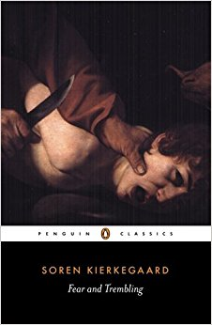
Fear and Trembling:
What is Story of Abraham and Isaac and why does Johannes de Silentio use it in “Fear and Trembling”?
The story of Abraham and Isaac is told in the book of Genesis and often referenced by Christians as an example of true faith. Abraham is considered by the Father of monotheism in the ‘Abrahamic faiths’; Christianity, Judaism and Islam because of his covenant with God. In the book of Genesis, after being promised many decedents by God, Abraham and Sarah finally conceive their son Isaac. Years later God puts Abraham under an extreme test of his commitment to their covenant. Abraham is told he must travel three days to sacrifice his son Isaac. He follows through with this instruction without doubt and is about to commit the act before an angel prevents him from doing so, leaving a sacrificial lamb in Isaac’s place.
For Johannes de Silentio, this story demonstrates the paradox of faith. Abraham was fully devoted to following the orders of God by acting in a manner most would agree is wholly unethical. He was prepared to sacrifice Isaac purely of the basis that his faith told him that God would have brought Isaac back from the dead had he been sacrificed. The conviction of his faith is heightened when considering the suffering Abraham and Sarah had waiting for God’s promise of having decedents to be fulfilled.
The case of Abraham transcends the ethical. He is considered to be a great man in the eyes of the Church despite the fact that his actions are clearly condemned by their own teachings as well as the majority of the public. In the book ‘Kierkegaard: An essential Introduction’, Michael Watts describes how the religious life is developed when someone realises “the ‘contradiction’ between the way they exist in their innermost soul and their failure to express this outwardly”. It is claimed this leads to “a state of ethical despair which if intense enough can precipitate a leap of faith, resulting in the religious outlook on existence.”
This is clearly seen with Abraham. He must take the leap of faith even though it goes completely against the ethical standards of his time. He knows he must do it as an individual prepared to live for God rather than society.

How does Fear and trembling pose a challenge to Christendom and Hegelian ethics?
Hegelian ethics stresses the importance of acting in accordance with the current social order. To be an ethical person means to do things for the good of the universal and the current law of the land rather than the individual. The dialectic system implies that culture is progressing, in a constant change from the thesis conflicting with the antithesis, resulting in the synthesis. The result of this thinking creates a situation where what is moral is relative to the time and society and that a person must act in accordance with this system.
For Johannes de Silento, this creates a problem. Hegelian ethics does not allow a ‘teleological suspension of the ethical’, in other words, there can never be good moral justification for an individual to act in accordance to something higher. What is right is right because it is currently the closest realisation of the eternal.
With regards to Christendom, the type of faith presented in Fear and Trembling makes a mockery of the type of Christian often seen in Denmark at the time. It requires a true decision to be made, one which could isolate you. The faith of Abraham is not rational and opposes the ethics of society. Most Danish Christians were considered to be Christian in name only for Kierkegaard and therefore any such notion of faith would likely be alien and insulting to them.
Why might faith be considered to be the highest state of being?
When reading Fear and Trembling it is important to keep in mind the books pseudonymous nature. Johannes de Silentio is clear that he is not a Christian and that this is what he considers faith to be. This means that this is not the final word on faith that Kierkegaard is going to produce. In fact, much or the terminology used throughout this book is not adopted again throughout the authorship. Similarly, Fear and Trembling was published very early in the writing career of Kierkegaard and therefore it is wise not to read this as an isolated text with no intention to discover more of what Kierkegaard has to offer.
Nevertheless, it does present the notion the individual moving from the ethical to faith, a theme which is revisited. Faith for Kierkegaard goes further than most people feel comfortable with. It is accepting the incarnation of Jesus and following his instruction as the only true guide to life. Consequentially, this means that religious scholars are to be looked down upon. By analysing the Gospels and interpreting their meaning for the current social climate, all you are doing is putting a distance between the message and yourself. For Kierkegaard this is softening the blow, making Christianity an easy life which anyone can achieve by taking part in sacraments such as Baptism, Eucharist and Matrimony. More importantly Kierkegaard felt strongly about the connection between state and religion. The fact that someone could declare themselves Christian purely on the basis of their national identity as a Dane meant that they had made no real commitment at all, they could not truly be classed as a religious individual.
True faith means not to be offended by the offering that Jesus gives to humankind and living your life in dedication to his standards. One must take a leap of faith in the paradox of God as human.
“The sign that someone has truly established a relation to the eternal aspect of existence is that their life becomes transformed by it. That person is not a religious believer, but a religious exister - their way of life is testimony to this fact, for they live in the truth. Thiers is also a life of ‘objective uncertainty’ because the validity of the genuine religious life cannot be rationally proven or justified.” (Kierkegaard: An Essential introduction)
Kierkegaard believes that this will overcome the issues that the aesthetic and the ethical lives leave you with. This is because you are serving the ultimate truth, with right intention. There is arguably an authenticity to these actions that a life of the aesthetic cannot provide.

The finite and the infinite. The path to a true self - Anxiety and despair
On the path to becoming a self, one is confronted with the human condition:
“For the self is a synthesis in which the finite is the limiting factor, and the infinite the expanding factor.”(The Sickness Unto Death)
For Kierkegaard the infinite is the part of us that realises all of the possibilities ahead of us, our imagination and our complete freedom to choose between the millions of options presented to us in our lives. Alternatively, the finite concerns itself with the present, our immediate situation.
It is likely that many people will lose themselves in either the finite or the infinite rather than establishing a balance between the two.
To lose yourself in the finite is to go through life one moment to the next without any real ownership of the choices you make. If you know someone who goes along with the group at any given situation or who has ended up in a job by complete circumstance then to Kierkegaard they are likely to be lost in the finite:
“too venturesome a thing to be himself, far easier and safer to be like the others, to become an imitation, a number, a cipher in the crowd.”(The Sickness Unto Death)
This will lead to despair, particularly when the person invests their entire identity into the group. They have no true sense of self and will be easily made angry or depressed if the group is threatened or dissolves completely.
To be lost in the infinite means to be paralysed by the amount of freedom we truly have as individuals. This could lead someone to never want to make important choices out of fear of regretting the outcome:
“Now if possibility [infinite] outruns necessity [finite], the self runs away from itself…The self becomes an abstract possibility which tries itself out with floundering in the possible, but does not budge from the spot, not get to any spot, for precisely the necessary is the spot; to become oneself is precisely a movement at the spot.”(The Sickness Unto Death)
This too leads to despair because the person fails to become a self.
Both of the previous examples could go unnoticed in many people and it is this which Kierkegaard believed to be the worst situation someone could experience. A person could be living a life of despair for decades without any self-reflection, completely lost:
“The biggest danger, that of losing oneself, can pass off in the world as quietly as if it were nothing; every other loss, an arm, a leg, five dollars, a wife, etc. is bound to be noticed.” (The Sickness Unto Death)
“The despairing man who is unconscious of being in despair is, in comparison with him who is conscious of it, merely a negative step further from the truth and from salvation. [U]nawareness is so far from removing despair, that, on the contrary, it may be the most dangerous form of despair. By unconsciousness the despairing man is in a way secured (but to his own destruction) against becoming aware—that is, he is securely in the power of despair.”(The Sickness Unto Death)

Quotes on Anxiety:
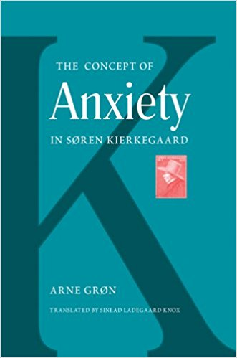
“Anxiety may be compared with dizziness. He whose eye happens to look down into the yawning abyss becomes dizzy. But what is the reason for this? It is just as much in his own eye as in the abyss, for suppose he had not looked down. Hence, anxiety is the dizziness of freedom, which emerges when the spirit wants to posit the synthesis and freedom looks down into its own possibility, laying hold of finiteness to support itself. Freedom succumbs to dizziness. Further than this, psychology cannot and will not go. In that very moment everything is changed, and freedom, when it again rises, sees that it is guilty. Between these two moments lies the leap, which no science has explained and which no science can explain. He who becomes guilty in anxiety becomes as ambiguously guilty as it is possible to become.” (Vigilius Haufniensis, The Concept of Anxiety)
“Whoever has learned to be anxious in the right way has learned the ultimate. … Anxiety is freedom’s possibility, and only such anxiety is through faith absolutely educative, because it consumes all finite ends and discovers all their deceptiveness. And no Grand Inquisitor has such dreadful torments in readiness as anxiety has, and no secret agent knows as cunningly as anxiety to attack his suspect in his weakest moment or to make alluring the trap in which he will be caught, and no discerning judge understands how to interrogate and examine the accused as does anxiety, which never lets the accused escape, neither through amusement, nor by noise, nor during work, neither by day nor by night.”— (Vigilius Haufniensis, The Concept of Anxiety)

How to become a self:
“To not be in despair is to have reconciled the finite with the infinite, to exist in awareness of one's own self and of love's power. Specifically, Kierkegaard defines the opposite of despair as faith, which he describes by the following:
‘In relating itself to itself, and in willing to be itself, the self rests transparently in the power that established it.’ People commonly ascribe the name ‘God’ to the ‘power that created’ the self, but Anti-Climacus's text is more subtle than this orthodox viewpoint. Kierkegaard certainly was thinking of God, but what it means to have a personal relation with God, and how God is love are the real subjects of this book.
While the book is, in many ways, a phenomenology of prayer; it is just as much a phenomenology of what a Romantic-despite-himself could offer to the future of human maturity by way of a relational view of the self as grounded in creative love. Certainly, it is this contribution, even more than the religious one, that made this text by Kierkegaard so important for 20th century philosophy and existential psychology.” – (https://en.wikipedia.org/wiki/The_Sickness_Unto_Death)

